**MINISTRY OF EDUCATION AND TRAINING**

**FPT UNIVERSITY**

Capstone Project Document

**QUESTION & ANSWER SYSTEM FOR MATHEMATICS**

|  |  |
| --- | --- |
| **Group 6** | |
| **Group member** | Nguyen Ngoc Thanh Hai – SE60916  Nguyen Dang Minh – SE60942  Than Van Tam – SE61014  Van Minh Hoang Quan SE61002 |
| **Supervisor** | Mr. Nguyen Ngoc Anh |
| **Ext. Supervisor** | N/A |
| **Capstone Project code** | CPMH |

Table of Contents

I. Project Information 1

II. Introduction 2

III. Similar Website research 2

1. Diễn đàn toán học (Vietnam Mathematics Forum) 2

2. Pitago.vn 4

3. Online Math 5

4. Mathematics 7

5. Code Project 8

IV. Current Situation 10

V. Problem Definition 11

VI. Proposed Solution 11

1. Main features 11

2. Advantages and Disadvantages 12

VII. Terminology 12

VIII. Project Team 14

1. Stakeholders 14

2. Norms 14

3. Rules 15

# Project Information

* Project Name: **Question & Answer system for Mathematics**
* Project Code: **MathHub**
* Product Type: **Website**
* Start Date: **May 11th 2015**
* End Date: **Aug 16th 2015**

# Introduction

MathHub is a website that help people easy to communicate, discussion and sharing knowledge about mathematics. MathHub worthy become home for everyone who love mathematics.

# Similar Website research

## Diễn đàn toán học (Vietnam Mathematics Forum)

* Info:
* Link: <http://diendantoanhoc.net/>
* Type: article, forum
* Topic: mathematics
* Posts: 463664
* Member: 78352
* Rank in Vietnam: 2605
* Total Sites Linking In: 179
* Established: 16/01/2014
* Belong to: Diễn đàn toán học (Vietnam Mathematics Forum)

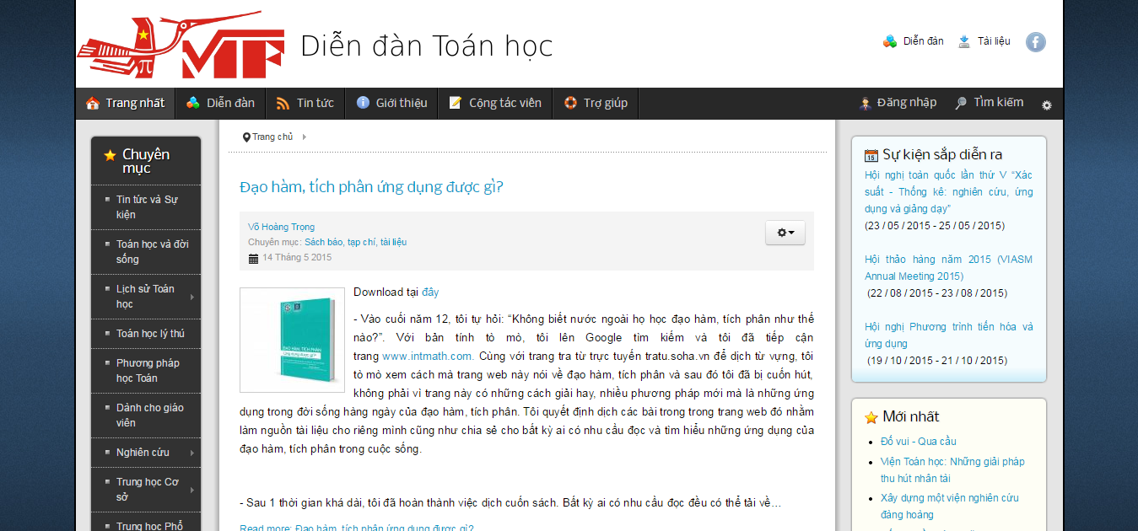

* Description:

Diễn đàn toán học (Vietnam Mathematics Forum) is a voluntary organization of young people in Vietnam who are studying and working in Vietnam and many countries around the world, was established to build an online yard of Mathematics for people who love math, teach math and study math. Diễn đàn toán học was officially put into operation on 16.01.2004, the first forum of the Vietnam Mathematics.

Diễn đàn toán học is an asset of the community and not influenced by any individual or organization. It was born from the community, to serve the community and well maintained by the community.

The operation of Diễn đàn toán học is based on two main parts: Homepage introduce news and articles, and forum where members meet and discuss all issues.

Math Forum is being managed and maintained (both human and power costs) by the Board of Trustees, is a group of scientists, teachers, researchers and students...

* Advantages and disadvantages:
* Advantages**:**
* Using LaTeX to write formulas.
* Organizing math contest.
* Having topics for each level (secondary, high school, university).
* Having "tags" to search easily.
* Disadvantages**:**
* Cannot login by Facebook or Gmail…
* Everything is posted (question, discussion, blog).

## Pitago.vn

* Info:
* Link: <http://pitago.vn/>
* Type: online learning, online test, QA system
* Topic: mathematics
* Rank in Vietnam: 37 600
* Total Sites Linking In: 16
* Belong to: Mạng Tri ThứcViệt Name company– Knetwork

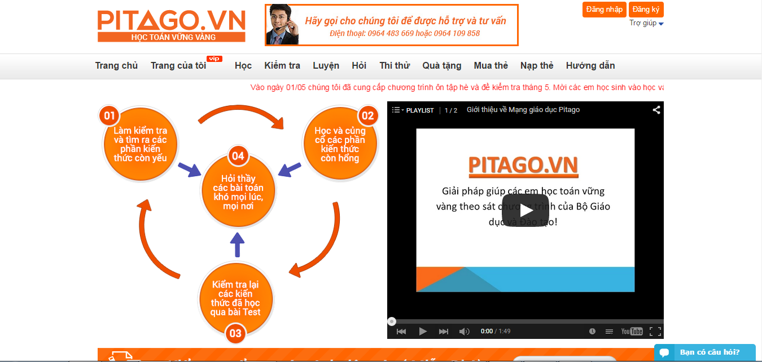

* Description:

Pitago publishes math solution to help study math steady that follow the curriculum. The first education network of Vietnam provides math tools. Built and contributed by leading education experts in the field of mathematics Curriculum.

* Advantages and disadvantages:
* Advantages**:**
* Tests weekly, monthly follow the program on class.
* Teachers evaluate guide and share knowledge.
* User practice from basic knowledge to advance knowledge.
* User asks expert when they have problem.
* Using LaTeX to write formulas.
* Another user can comment.
* Disadvantages**:**
* Limiting level to study (Class 3 to 9).
* Must pay to see the full solution.

## Online Math

* Info:
* Link: <http://olm.vn/>
* Type: online test, QA system
* Topic: mathematics
* Rank in Vietnam: 2 793
* Total Sites Linking In: 15
* Belong to: Computational Science Center - Hanoi National University of Education - JSC Science and Technology Education

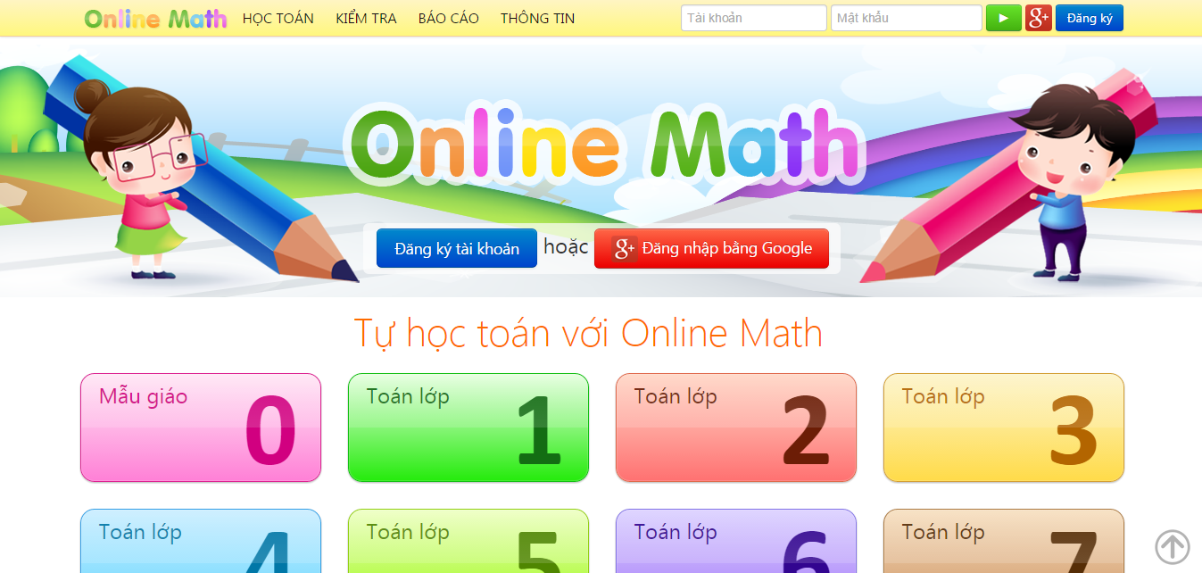

* Description:

Online Math is an online learning system to help students learn math easily and efficiently. On Online Math, the teaching and learning content is organized into a set of skills. There are many various exercises that are integrated in an intelligent learning scenario.

* Advantages and disadvantages:
* Advantages**:**
* Math expert give solutions.
* Support drawing.
* Using Math formulas editor.
* Sorting by the best answer.
* Having "tags" to search easily.
* Bookmark the questions.
* Having system rating help improve reliability.
* The person who asked can choose the best answer.
* Disadvantages**:**
* Compiling content for secondary school.
* Limiting questions in 1 day (5 questions).
* Not share good articles with Facebook, Gmail.
* Not have Report violation.
* Not have "reputation".
* Cannot live chat.
* Not allow close question.

## Mathematics

* Info:
* Link: <http://math.stackexchange.com/>
* Type: QA system
* Topic: mathematics
* Rank in Global: 165
* Total Sites Linking In: 23 098
* Belong to: Stack Exchange Inc.; user contributions licensed under cc by-sa 3.0 with attribution required

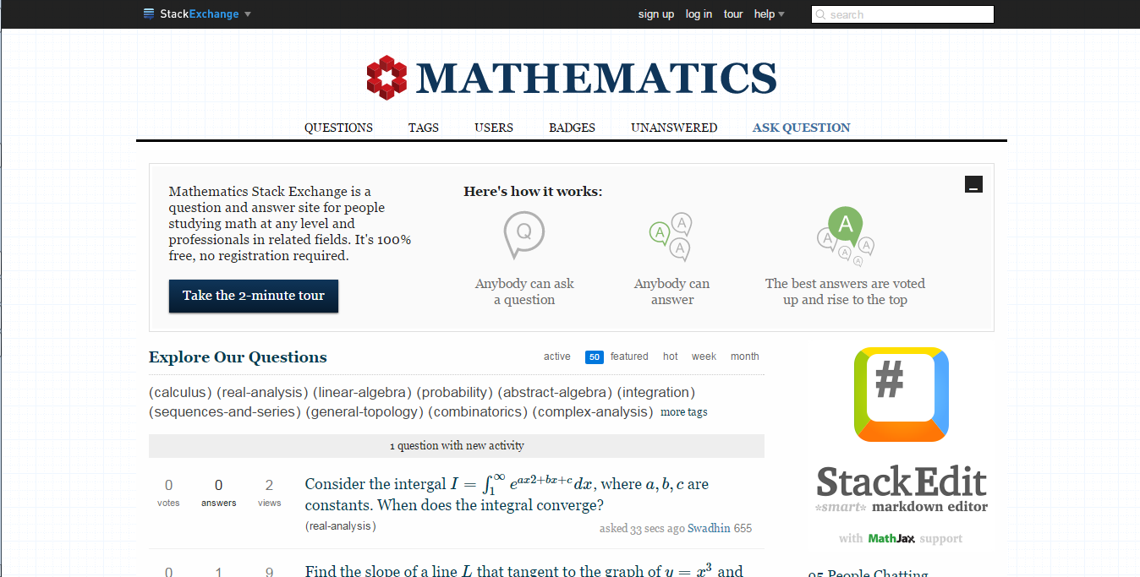

* Description:

Mathematics Stack Exchange is a question and answer site for people studying math at any level and professionals in related fields. It is built and ran by you as part of the Stack Exchange network of Q&A sites. With user in the world, they build a library of detailed answers to every question about math.

* Advantages and disadvantages:
* Advantages**:**
* Good answers are voted up and rise to the top.
* The person who asked can mark one answer as "accepted".
* Tags make it easy to find interesting questions: each question can have 5 tags.
* You earn reputation when people vote on your posts.
* Improve posts by editing or commenting:
* If you see questions or answers that can be improved, you can edit them.
* Use comments to ask for more information or clarify a question or answer.
* Signing up with Facebook or Gmail…
* Share question via Facebook, Gmail.
* Disadvantages**:**
* Enter mathematical formula is difficult.
* Not support drawing.
* Not allow attach file or image.

## Code Project

* Info:
* Link: <http://www.codeproject.com/>
* Type: community of Software development and Design developers
* Topic: programming, source code
* Rank in Global: 1 212
* Total Sites Linking In: 17 226
* Belong to: Code Project

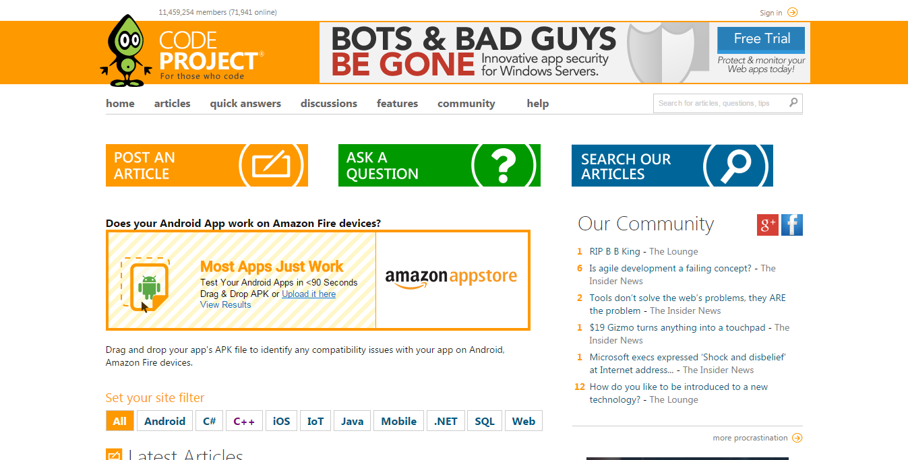

* Description:

CodeProject is a community of Software development and Design developers joined certain common goals: to learn, to teach and to have fun programming. Developers from all over the world come together to share source code, tutorials and knowledge for free to help their fellow programmers.

* Advantages and disadvantages:
* Advantages**:**
* Share source code, tutorials and knowledge for free to help their fellow programmers.
* Have discussion boards and support for code with the buttons.
* Post articles and vote on other authors' articles.
* The Lounge: to get together and ask advice to tell bad jokes and keep up with the latest industry gossip.
* Bookmark your favorite articles.
* Have your signature, name and contact details filled in automatically when posting to the discussion boards.
* Reserve your name. Once your name has been taken, one else can pose as you on the discussion boards.
* Have tag.
* Having system rating help improve reliability.
* Signing up with Facebook or Gmail…
* Share good articles with Facebook, Gmail, and Skype …
* Disadvantages**:**
* If user wants to view the comment, they must click each one.

# Current Situation

The mathematics community in Viet Nam is a large community with over 10,000 people, they really need an official site for them to communicate, discussion and sharing knowledge. There are some websites about mathematics in Viet Nam, but no site can meet their needs.

Almost mathematics websites in Viet Nam are one of 2 types: Study site and Forum.

* + Study sites just help people study and do exam online, people cannot communicate or discussed in these sites. So that these sites are necessary, but cannot become official site for mathematics community. There are some study sites in Viet Nam: [pitago.vn](http://pitago.vn/), [olm.vn](http://olm.vn/), [olympiaplus.vn](http://olympiaplus.vn/); but there are not famous and some sites just for high school students.
  + Forum is a very good place for people to communicate and discussion, but in recent time forum gradually revealed many weaknesses since the advent of social networks. The first main weakness is that user post question, discussion, sharing knowledge … into forum, so that it cannot have a clear rule to prevent the noise. User post a question and maybe receive a lot of discussion, but without any solution; this is really a big noise but usually appear in forum. Another weakness is that forum does not have some social functions like add friend, live chat and follow so that users hard to communicate and interact together. There are 2 famous mathematics forum in Viet Nam: [mathscope.org](http://forum.mathscope.org/) and [diendantoanhoc.net](http://diendantoanhoc.net/), each site has thousands member but still was not leading site in the mathematics community.

In foreign countries, people gradually like Question – Answer (QA) sites, these sites are helpful when people want an answer for their question as soon as possible. There is a very famous QA site is [stackexchange.com](http://stackexchange.com/). The things make this site become difference are that they only focus on QA and has a great scoring system (vote up and vote down).

# Problem Definition

* Mathematics community needs a website as a home that they can easily communicate, interaction, discussion, sharing knowledge.
* Users only need answer (but discussion or noise) for their question as soon as possible that forum cannot help.
* Users need a place that they can show their best and gain reputation in the community.

# Proposed Solution

After research a lot of domestic and foreign, we decide to develop MathHub that gathers strengths of famous sites to meet the needs of the mathematics community in Viet Nam. MathHub will become a home for them to communicate easily, interaction, discussion, sharing knowledge.

## Main features

* With QA, system people will get answers for their question very easy and fast. Moreover, they also have reputation in the community if their answer was voted up a lot via scoring system.
* With Discussion – a system like a forum that will be a great place for people who want to discuss with other about mathematics.
* With Blog, people also can share their knowledge to another or they just want to store great solutions for some problems.
* Social functions like add friend, follow, live chat, notification and invite friend to a post will really helpful for people in community to communicate together.

## Advantages and Disadvantages

* Advantages:
  + - * People will get answers to their question very easy and fast without noise.
      * People have reputation in the community when they are active and positively contribute to the community.
      * Website has many functions for users to communicate and interact together easily.
      * User can use LaTeX to write math formulas.
* Disadvantages:
  + - * Website was not support user to draw in geometry.
      * Many users in Viet Nam are not familiar with QA system.
      * Not support mobile version.

# Terminology

|  |  |  |
| --- | --- | --- |
| **No** | **Terminology** | **Meaning** |
| 1 | **Question & Answer system (QA system)** | This is a system functions of website to help users post question and answer. |
| 2 | **Blog system** | This is a system functions of website to help users post articles to sharing knowledge. |
| 3 | **Discussion system** | This is a system functions of website to help users discussion some problem together. |
| 4 | **Scoring system** | This is a system functions of website to help users vote for Question or Answer they like or dislike. Moreover, users who be voted will gain reputation in community. |
| 5 | **Post** | This is abstract name to call Question, Answer, Comment, Blog, and Discussion. |
| 6 | **Question** | It is used to call a question that user post into QA system. |
| 7 | **Answer** | It is used to call an answer that user post into QA system. |
| 8 | **Article** | It is used to call an article that user post into Blog system. |
| 9 | **Discussion** | It is used to call a discussion that user post into Discussion system. |
| 10 | **Comment** | It is used to call a comment that user comment to Question, Answer, Blog, Discussion and reply other comment. |
| 12 | **Group** | Use in blog system. Some users will join as a group. If group’s member post article into group, this article will belong to group. |
| 13 | **Report** | It is a function help user report violate posts. |
| 14 | **Vote up** | It is a function in Scoring system for user to vote Question or Answer they like. |
| 15 | **Vote down** | It is a function in Scoring system for user to vote Question or Answer they dislike. |
| 16 | **Tag** | It is used to call a tag (or also call label) to classify Question, Article, Discussion. |
| 17 | **Follow** | If Users follow a post, they will receive notification for events of this post like comment, answer … |
| 18 | **Subscribe** | Use in blog system. If Users subscribe another user or a group, they will receive notification when a new article posted. |

# Project Team

## Stakeholders

|  |  |  |  |  |
| --- | --- | --- | --- | --- |
| **No** | **Name** | **Role** | **Position** | **Email** |
| 1 | Nguyễn Ngọc Anh | Project Manager | Instructor | anhnn4@fpt.edu.vn |
| 2 | Nguyễn Ngọc Thanh Hải | Developer, BA, Designer, SA | Team leader | hainntse60916@fpt.edu.vn |
| 3 | Nguyễn Đăng Minh | Developer, BA, Designer, SA | Team member | minhndse60942@fpt.edu.vn |
| 4 | Văn Minh Hoàng Quân | Developer, Tester, BA | Team member | quanvmhse61002@fpt.edu.vn |
| 5 | Thân Văn Tâm | Developer, Tester, BA | Team member | tamtvse61014@fpt.edu.vn |

## Norms

* Team members as coworkers: all team members are equal; every team member's opinion will be thoughtfully considered; each team member will keep all commitments by the agreed upon due date.
* Team member communication: team members will speak respectfully to each other; will not talk down to each other; will positively recognize and thank each other for team contributions.
* Team member interaction in meetings: team members will listen without interrupting; hold no side or competing conversations; follow the rules for effective meetings; attend the meeting on time; always work from an agenda.
* Team problem solving, conflicted resolution, and decision-making: team members will make decisions by consensus, but the majority will rule if timely consensus, not reached; conflicts will be resolved directly with the persons in conflict.

## Rules

* Respect the majority's opinion.
* Always express your views.
* Must ask another member for support when meet difficult problems.
* Restrict make decisions without team discussion.
* Must finish tasks on time. Penalize 10k when delays task.
* Can change deadline or change task if cannot handle.
* Do not commit error code to source server.
* Do not resolve conflict if it relates to another’s code.